Views
Label

Description: Text used to display information to the user.
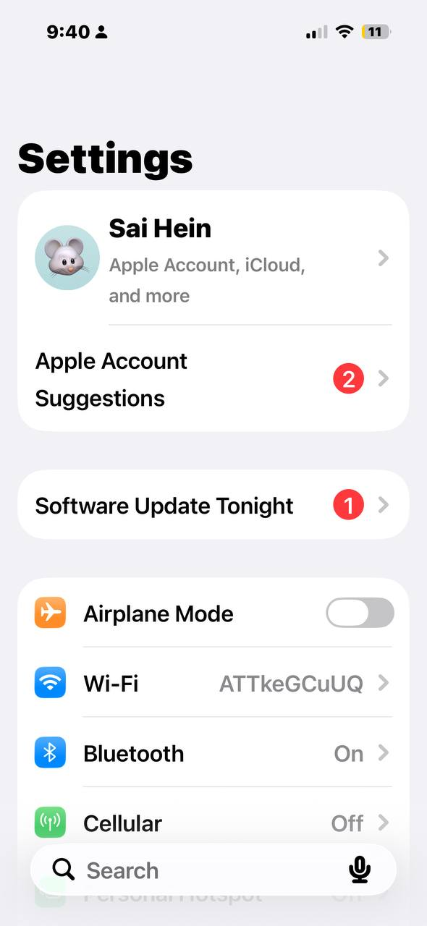
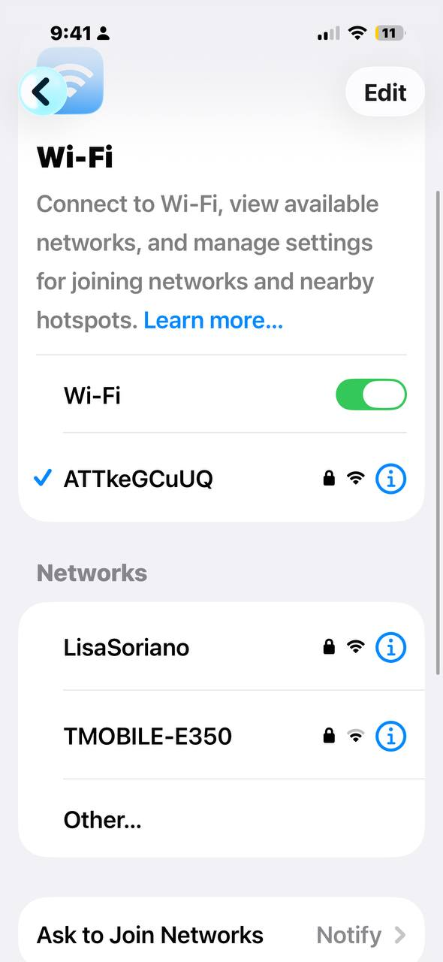

Image View

Description: Displays images or icons in the interface.
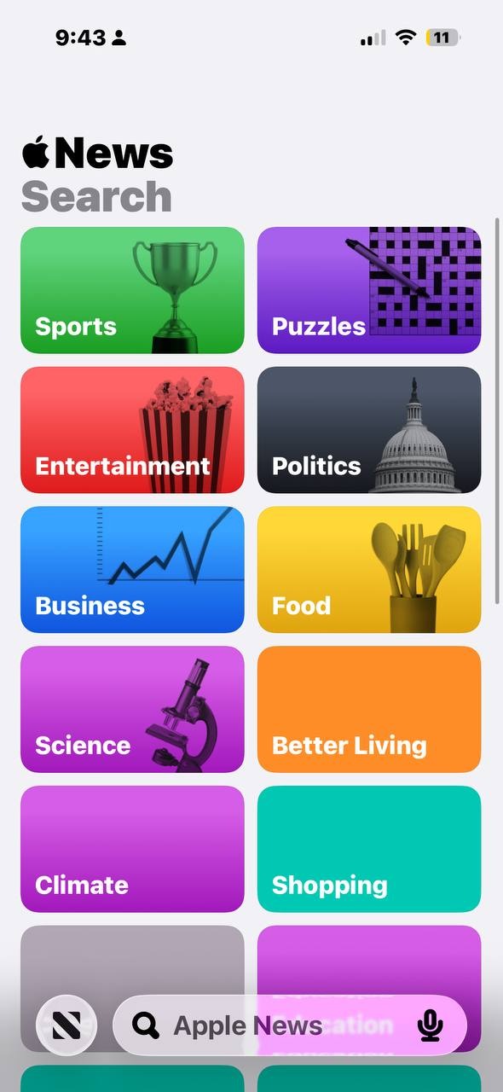

Text View
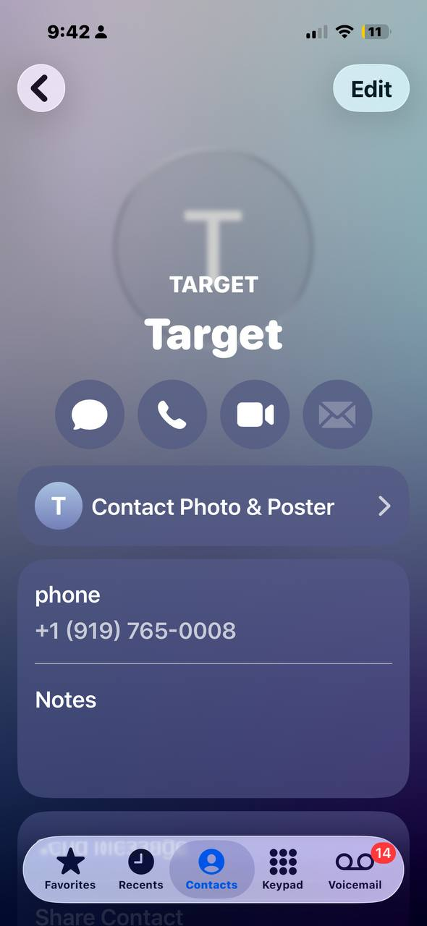

Description: A multi-line area where users can read or edit text.

Table View
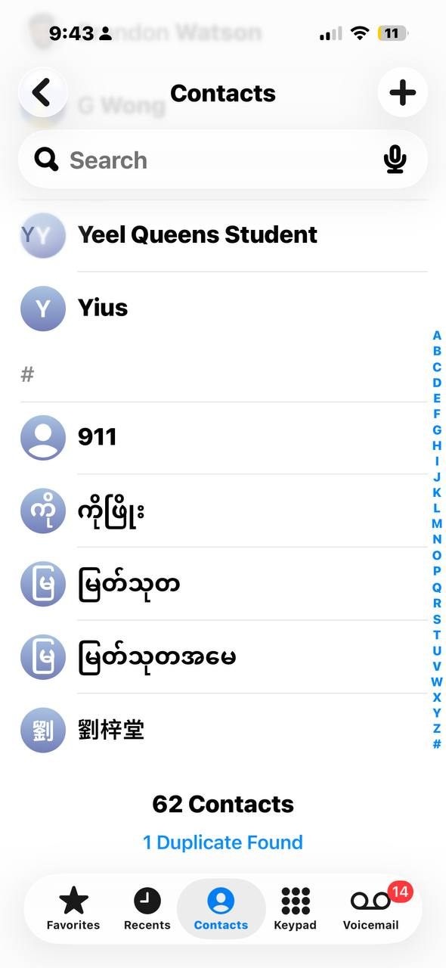

Description: A scrollable list of items arranged in rows (for example, the Settings list).

Navigation Bar


Description: The bar at the top of the screen that shows the title and navigation buttons.

Tab Bar
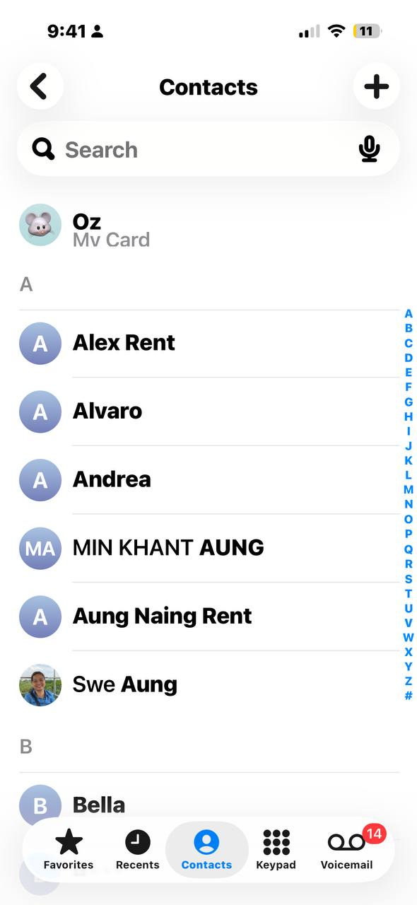
Description: A bar at the bottom of the screen used to switch between different sections of an app.

Controls
Button
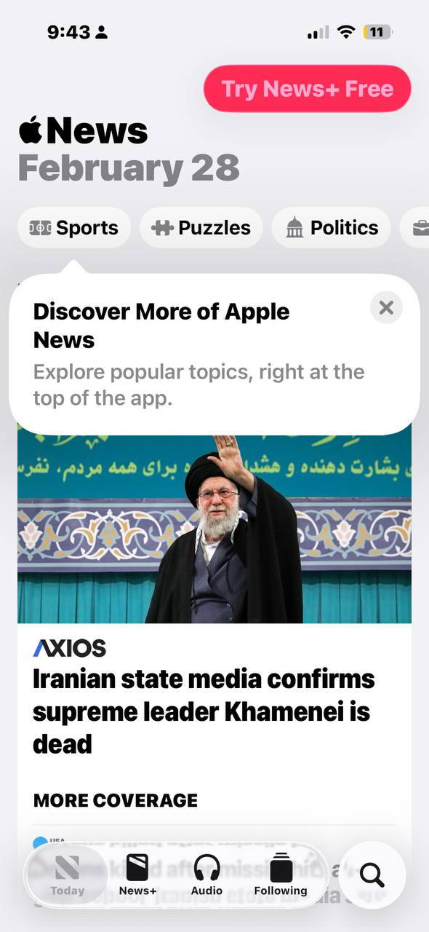
Description: A control that performs an action when tapped.

Segmented Control

Description: A control with multiple segments used to switch between different views or options.

Text Field
Description: A single-line field where the user can type text.
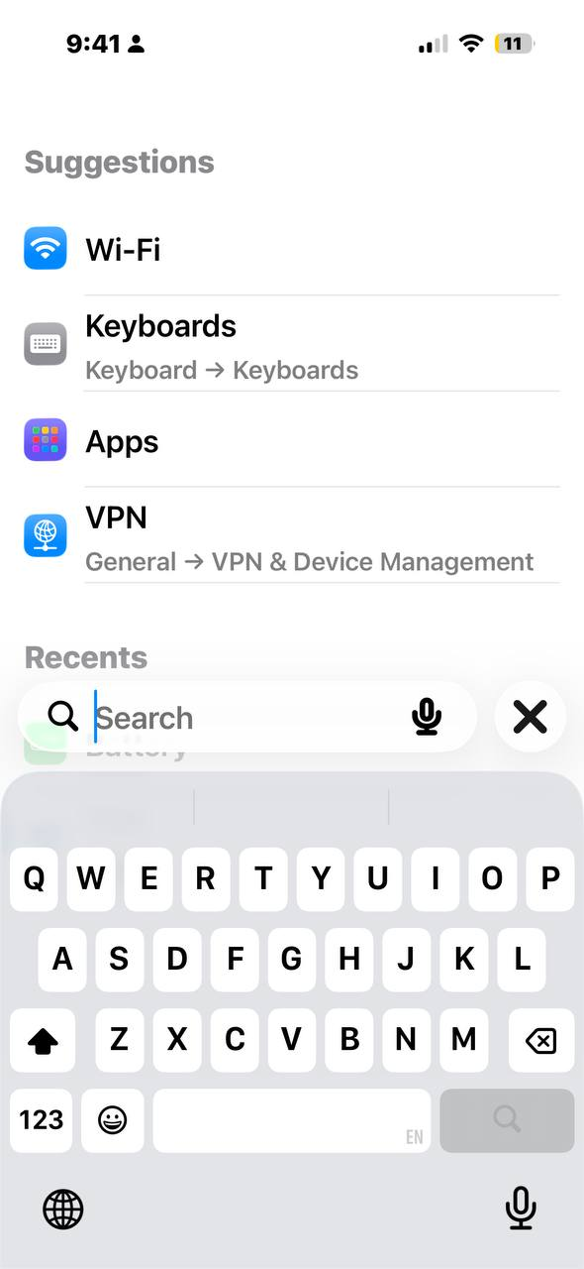

Slider

Description: A control used to choose a value between a minimum and maximum by dragging a handle.

Switch

Description: A control used to toggle a setting on or off.

